Characterize the Net Promoter Score data using R.

Step 1:

Open R Studio.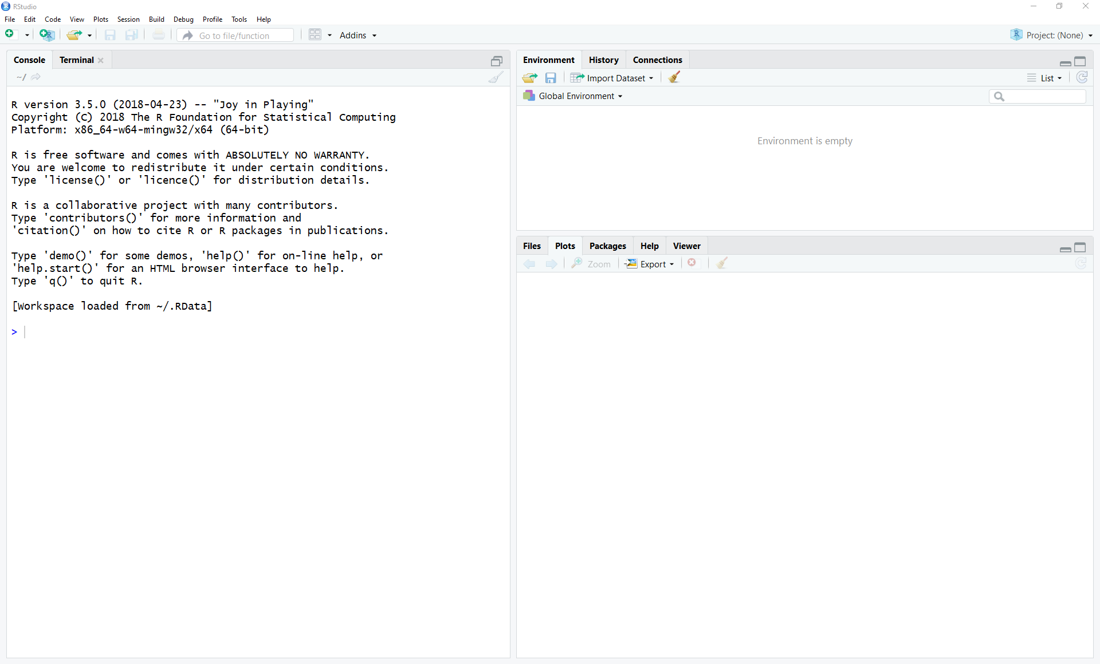

Step 2:

Click on Import Dataset in upper right pane

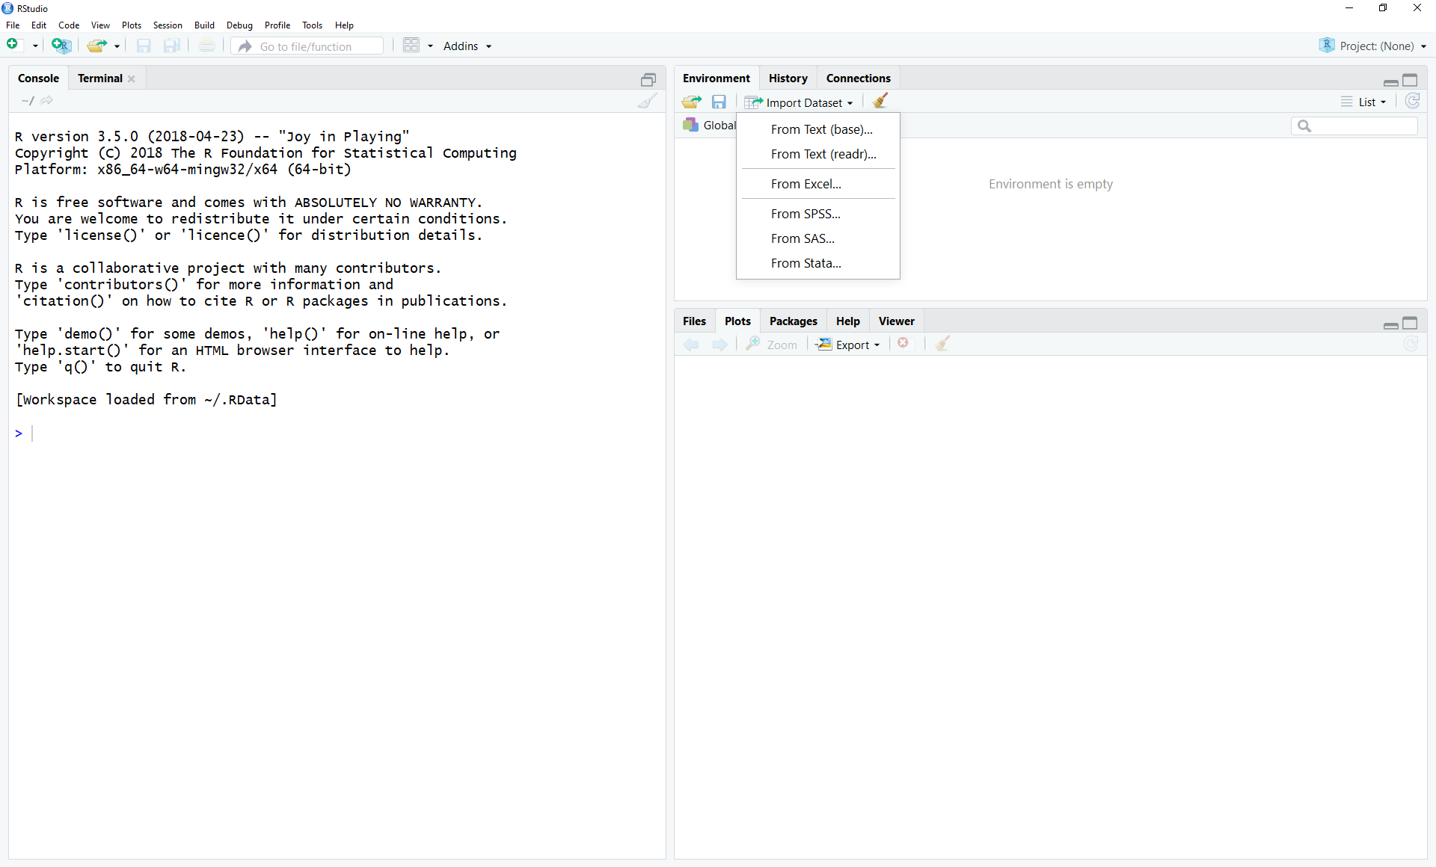

Step 3:

Verify that the importer will import data as you want it to be. Check the variable name and column names.

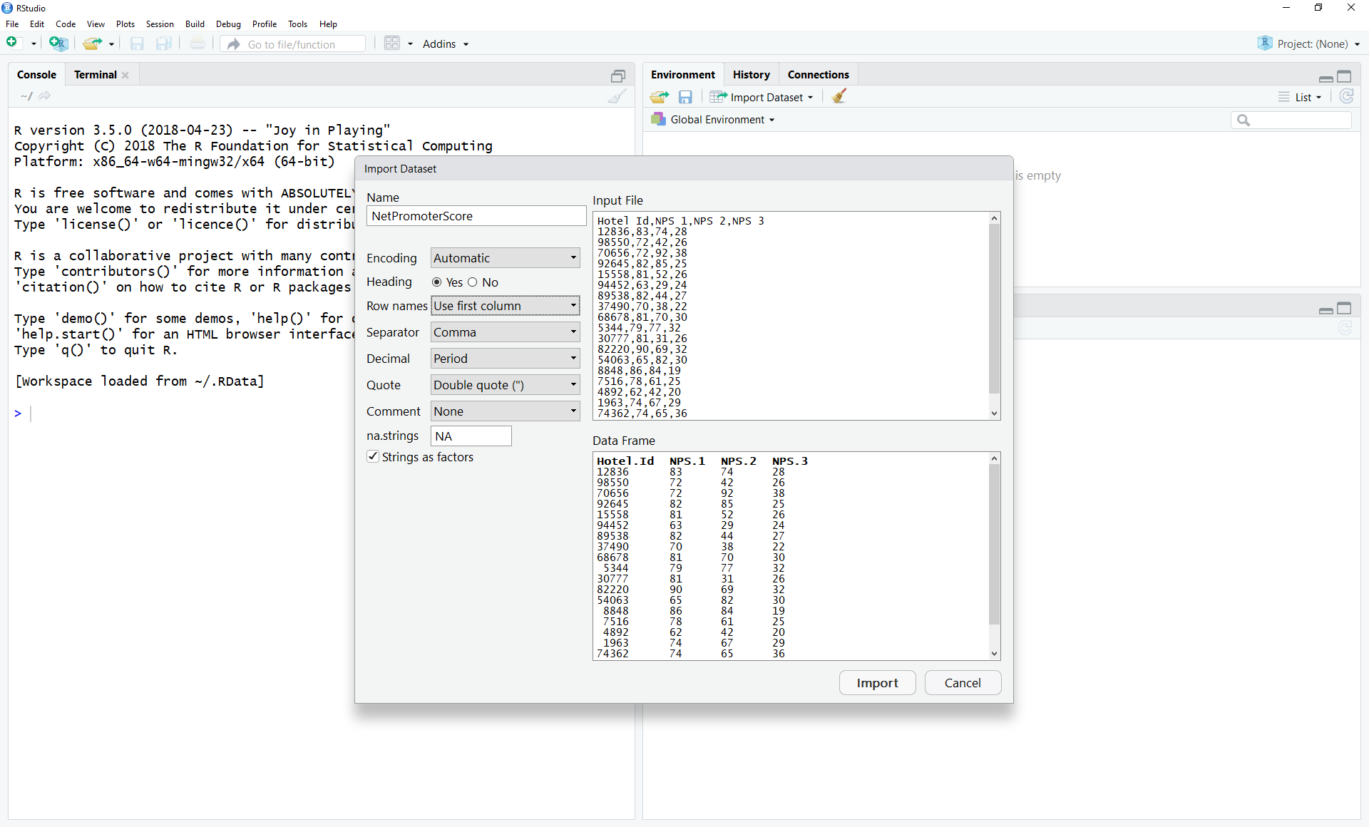

Step 4:

Execute the lines at the bottom of the console shown here to view the data in the first column, to access the first element of the first column and to access the row for record 98550

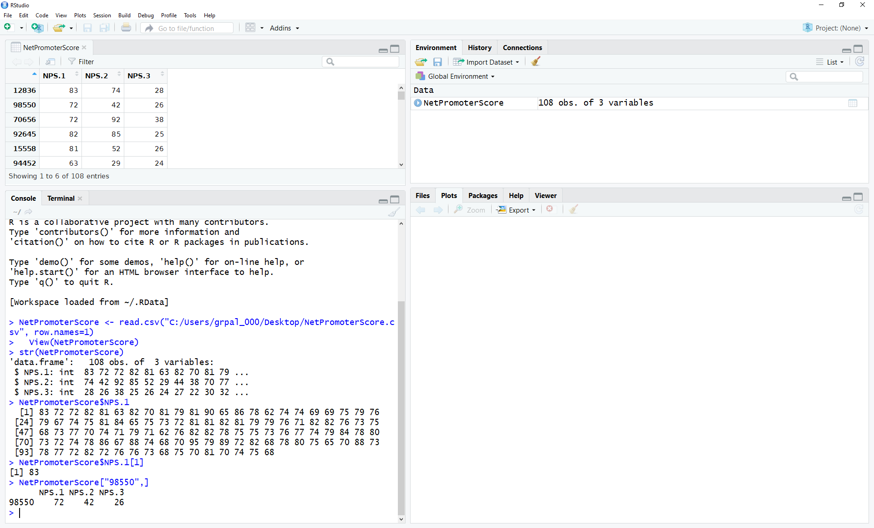

Step 5:

Execute the summary() command to view the quartiles, averages, and range and each column.

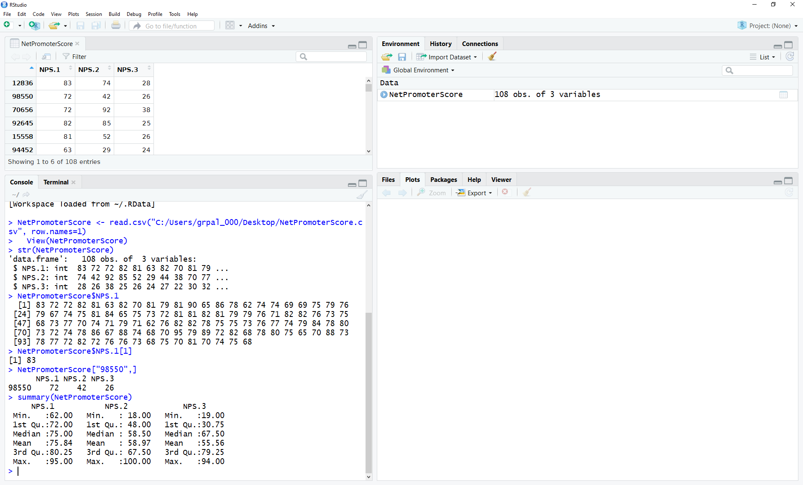

Step 6:

Use the help function on “summary” to view the documentation.

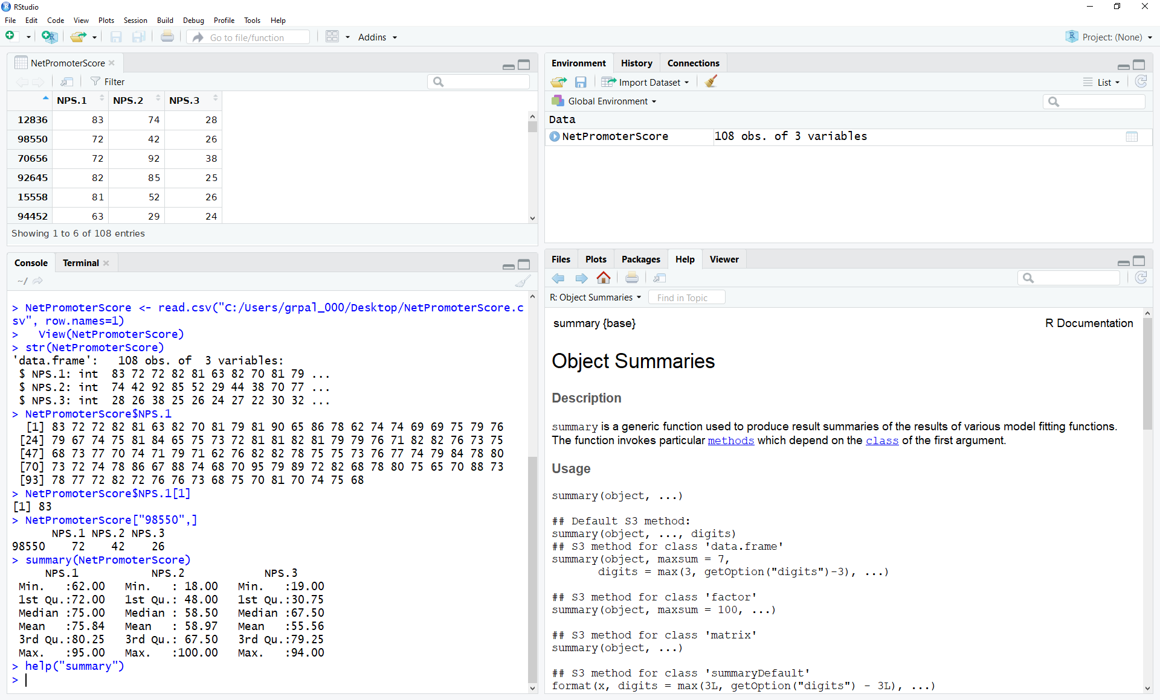

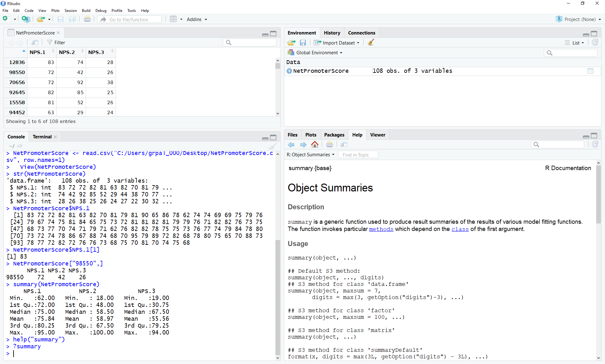

Step 7:

Explicitly calculate the summary statistics for the columns as shown in the following screenshots.

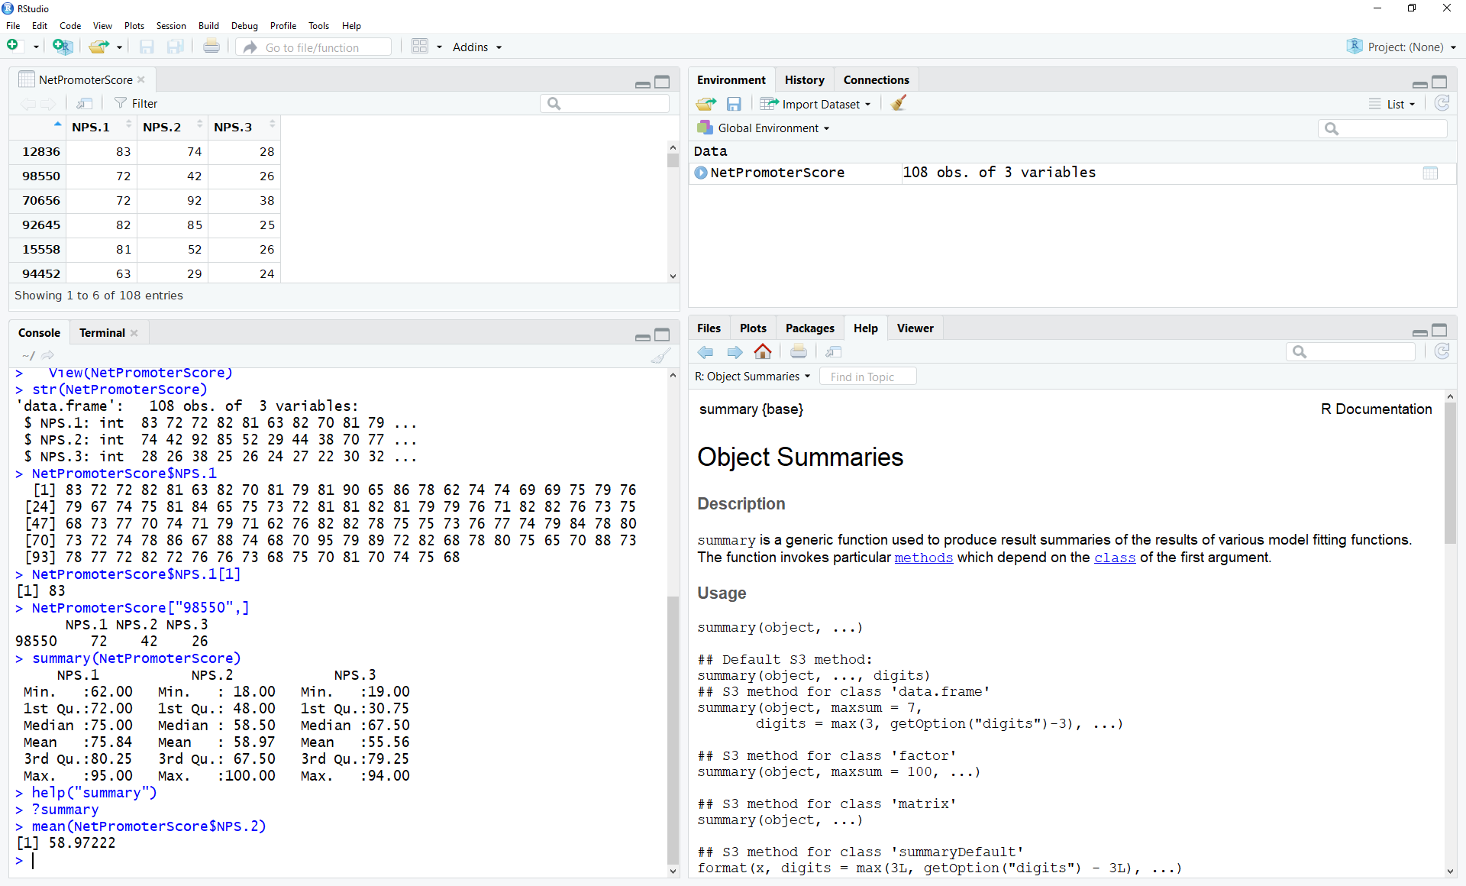

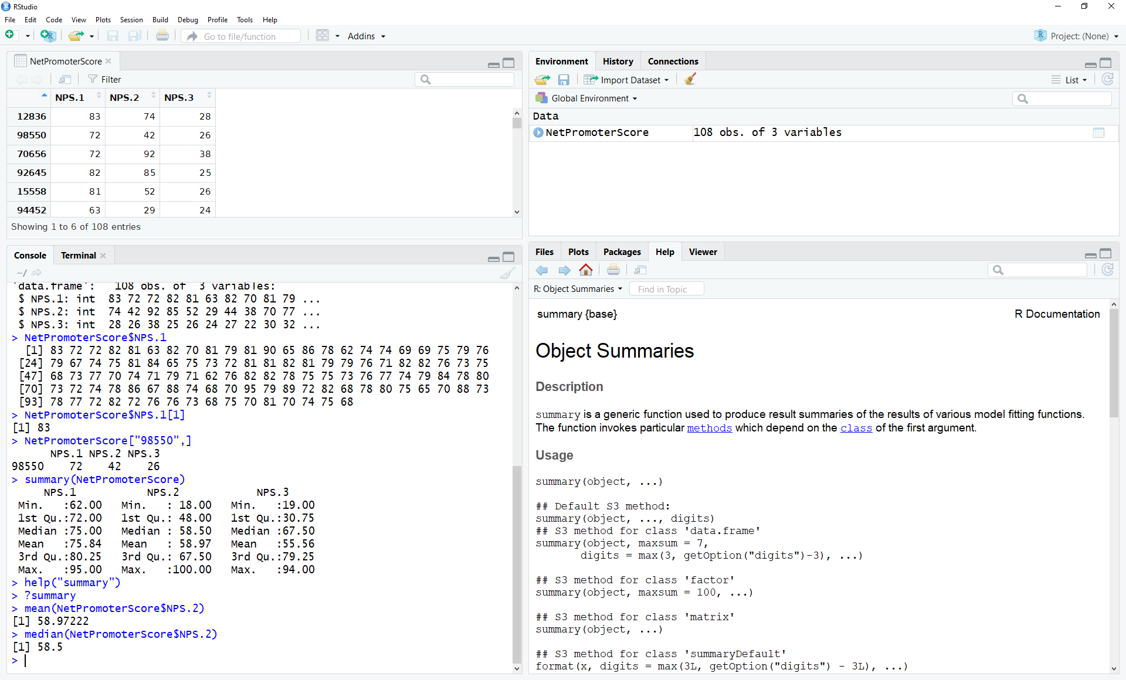

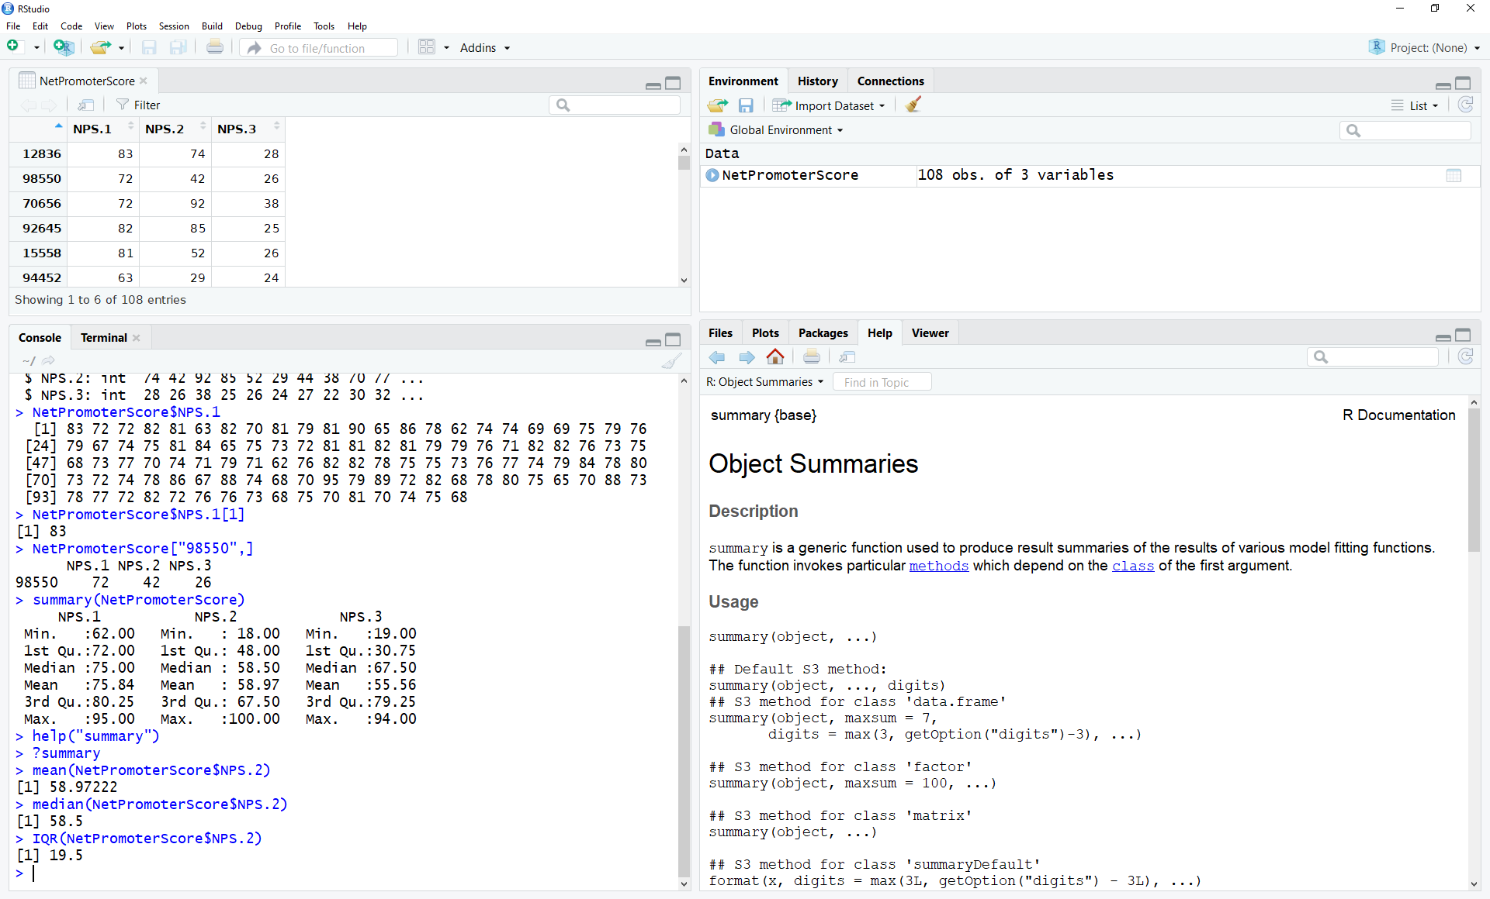

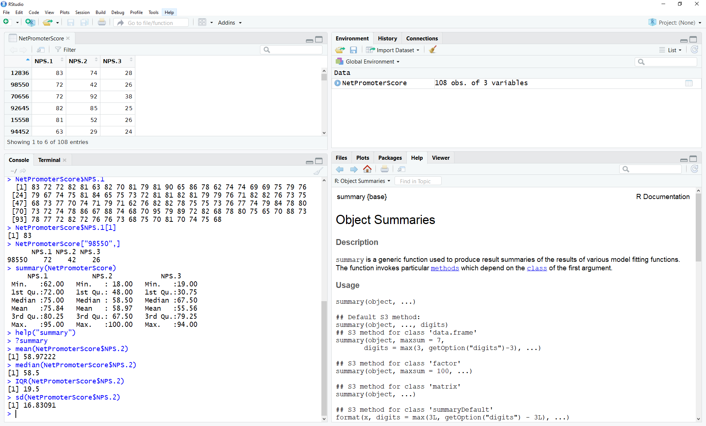

Step 8:

Visualize the data with the commands below using the stripchart() function

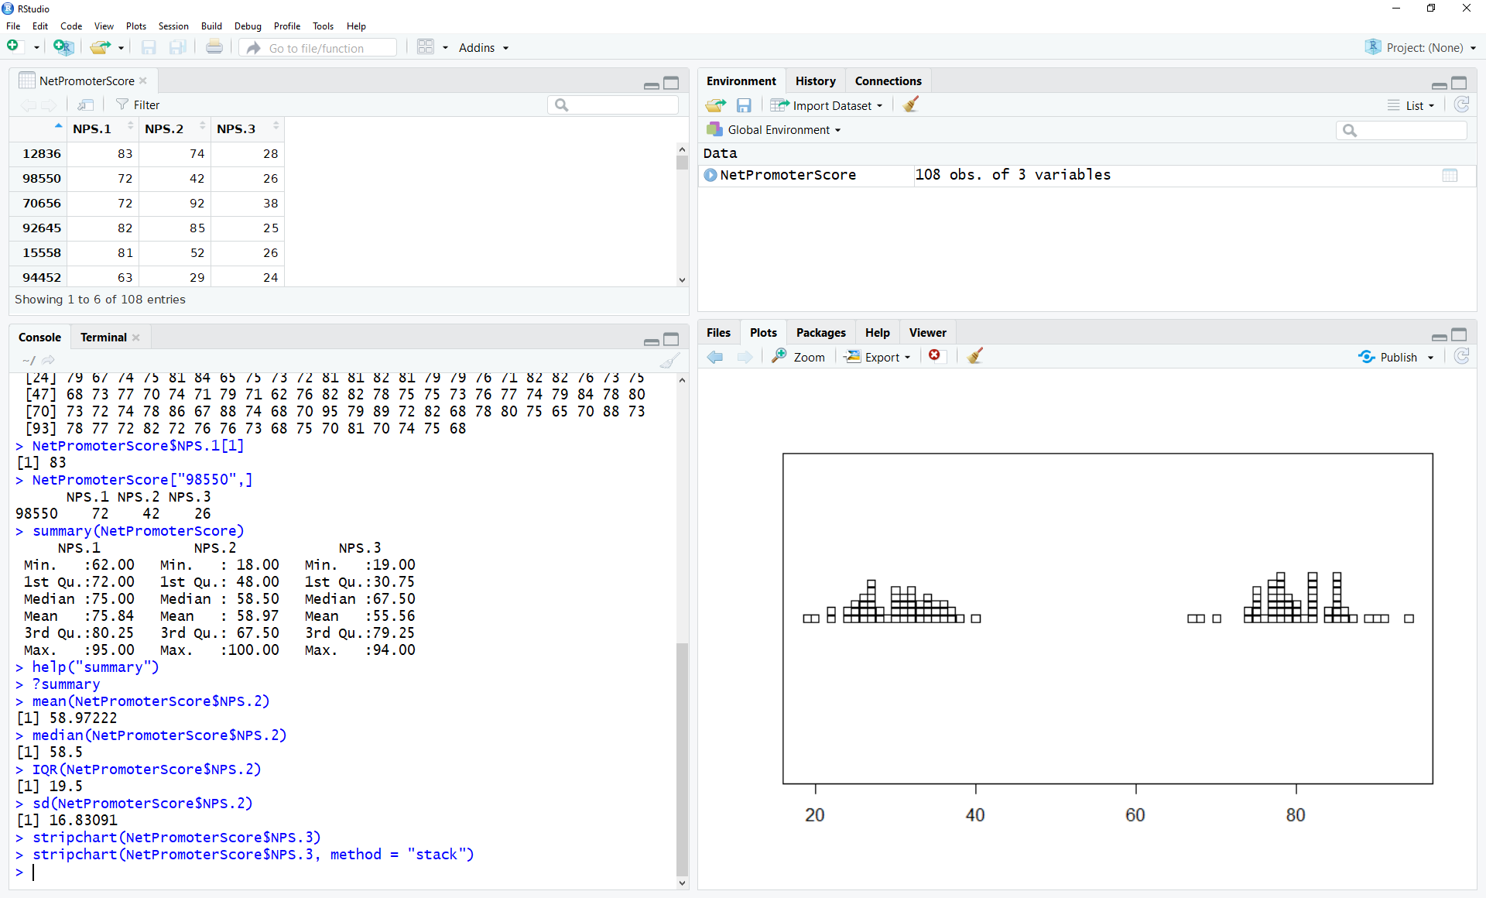

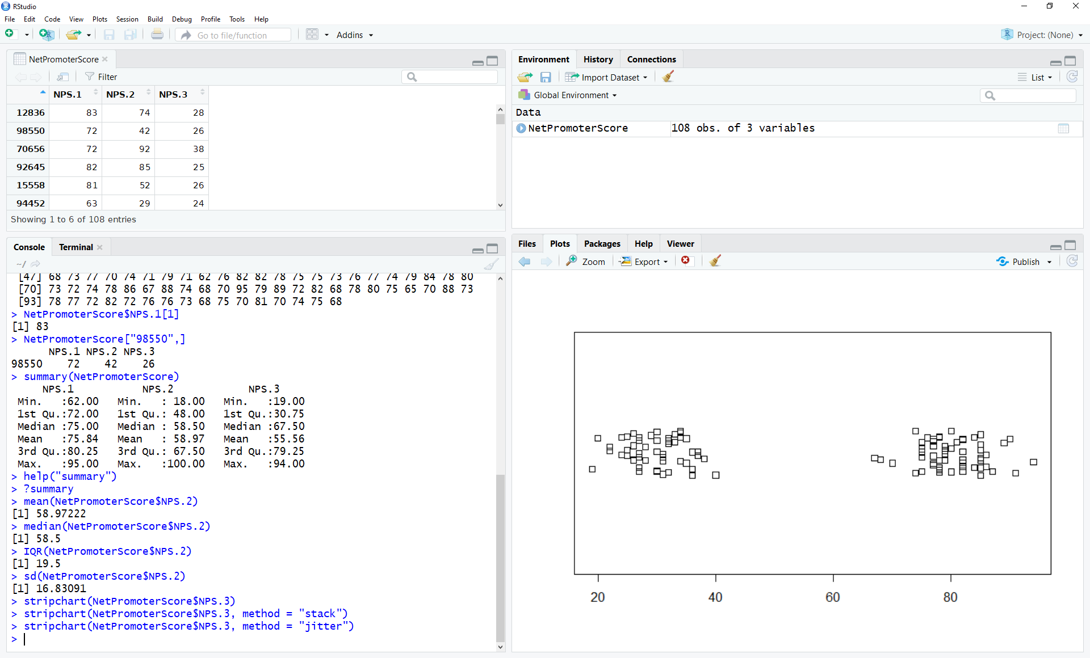

Step 9:

Use hist() to plot histograms of your data.

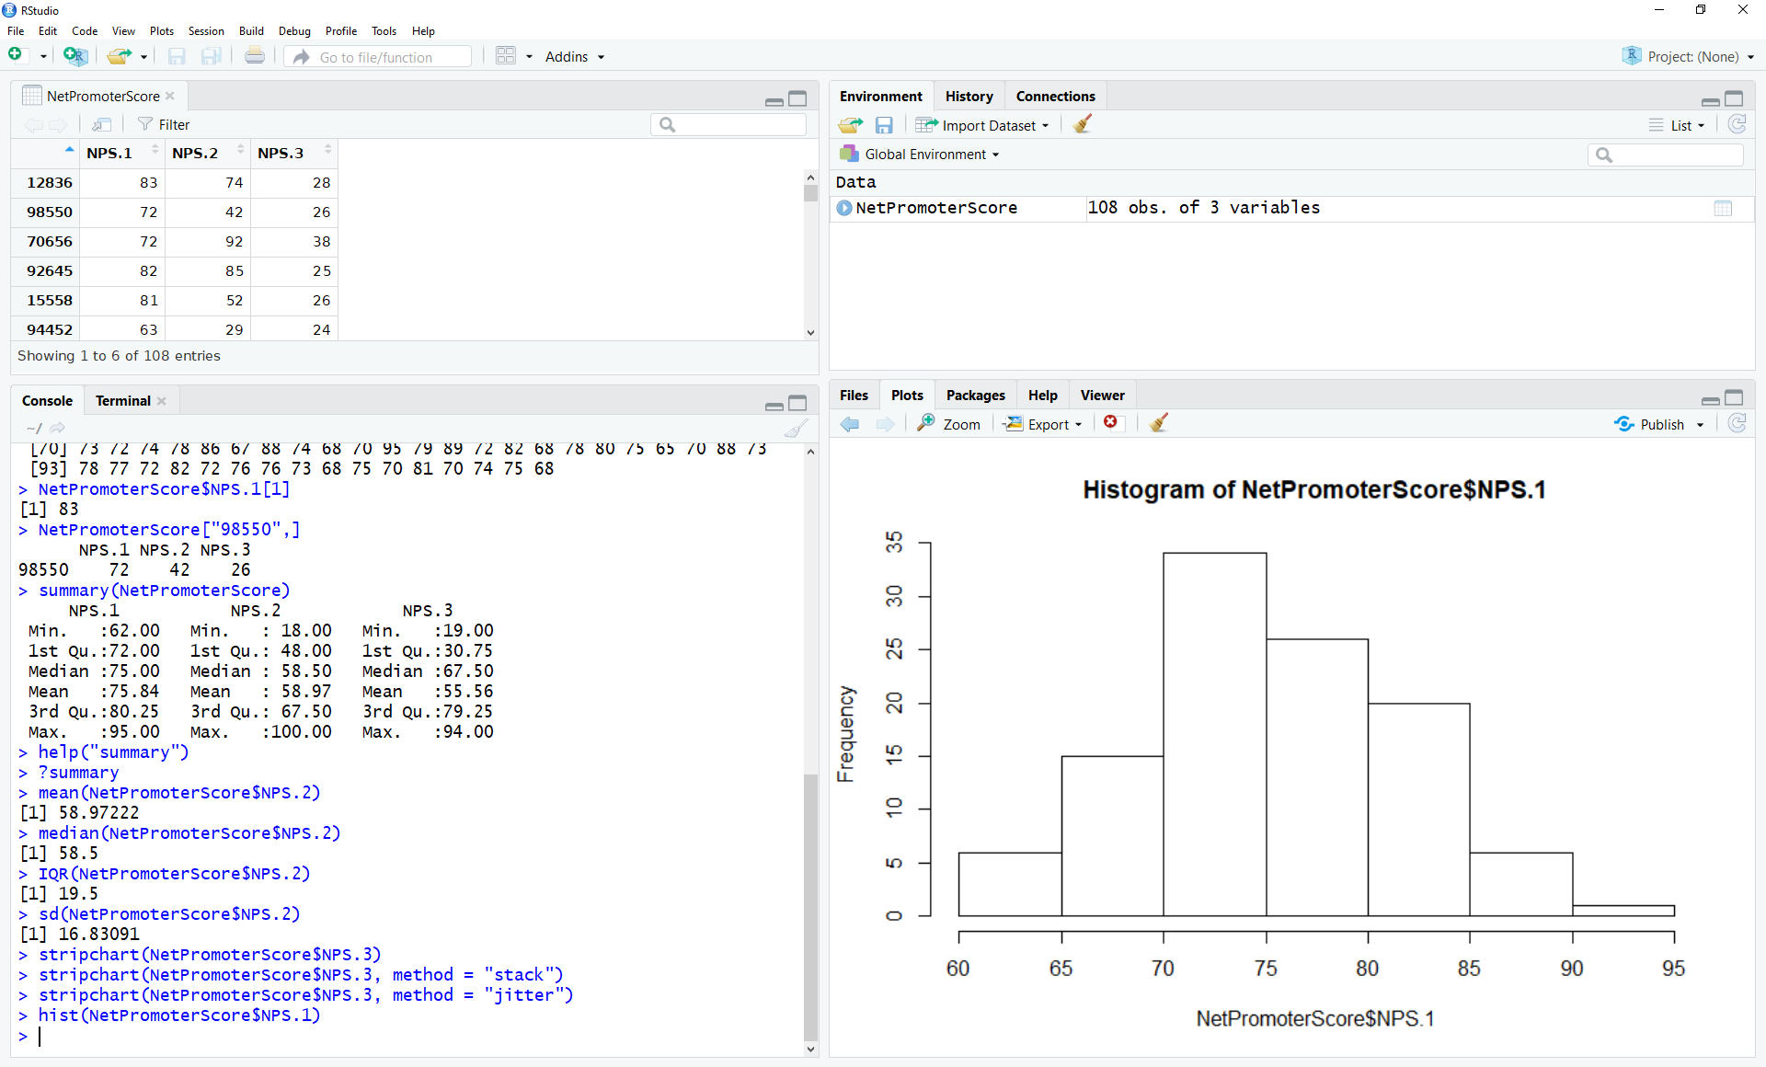

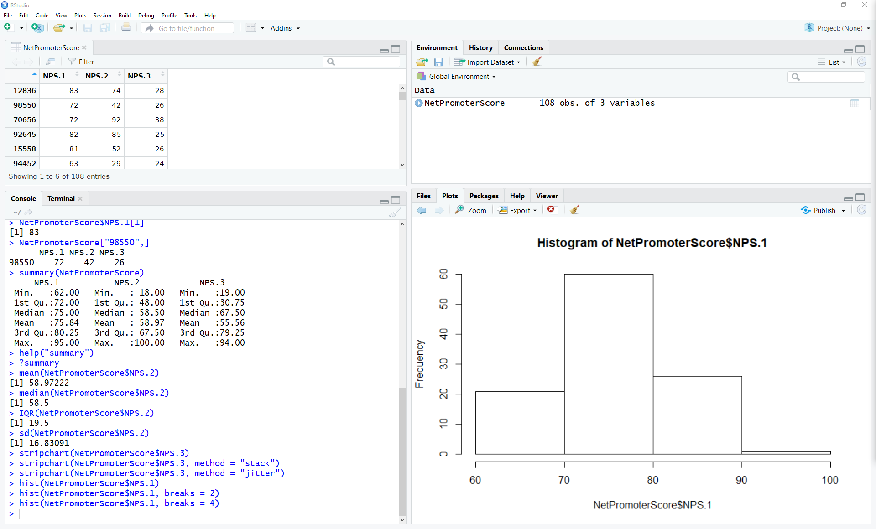

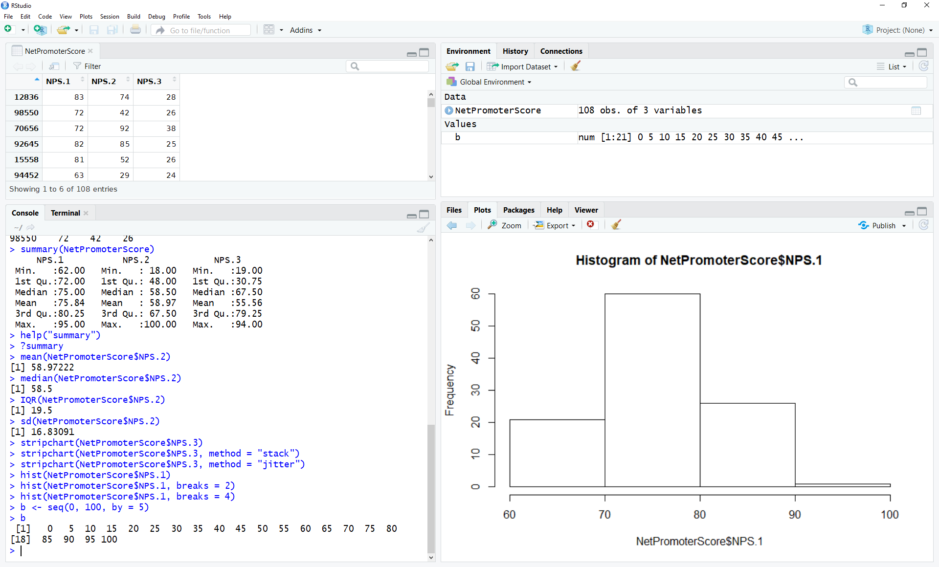

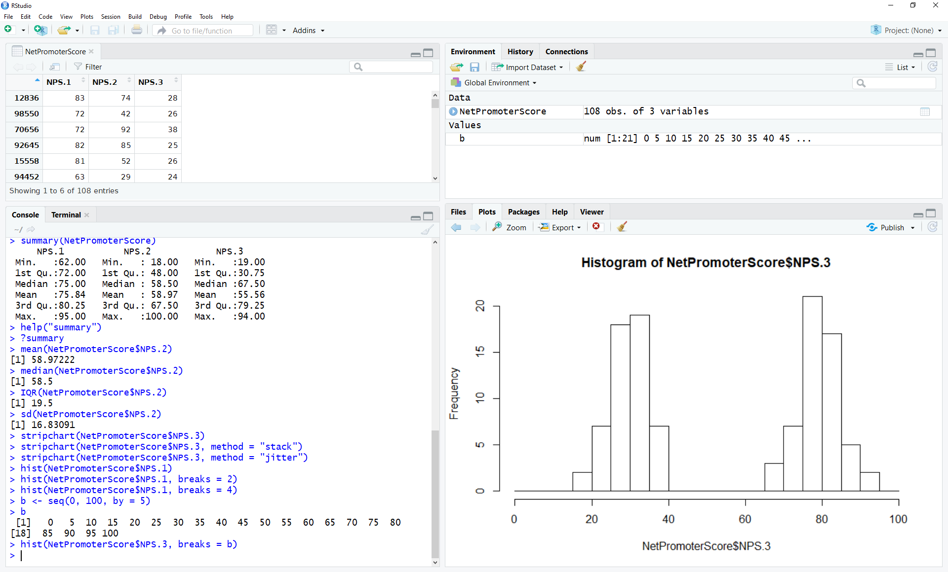

Step 10:

Plot the IQR box plot for the data

